# Create Database and Tables in SSMS

This tutorial walks you through the steps of creating a new database on SSMS and using the provided DDL script (hubspot) to create your database tables. After completing this tutorial, you will move on to SQL Server Integration Services Tutorial and create an ETL flow using SSIS. SQL Server Integration Services Tutorial will require you to enter the SQL Server name and the name of database and tables you will create in this tutorial. Therefore, please make sure you have completed this tutorial before moving to the SQL Server Integration Services Tutorial.

Some software and extensions are required to be able to follow this tutorial. Therefore, first you need to connect to your remote desktop at CBA Virtual Analytics lab, where the required software and tools for this tutorial are pre-installed, before proceeding with the tutorial. Please go to this page to register and learn how you can access to CBA Virtual Analytics lab: [CBA Virtual Analytics Lab - Individual Data Science Virtual Machines](https://canvas.uw.edu/courses/1492912/pages/cba-virtual-analytics-lab-individual-data-science-virtual-machines)

Prerequisites

Below software and tools are required for this tutorial and these are already installed on your remote desktop at CBA Virtual Analytics Lab. Therefore, instead of installing these software you can connect to CBA Virtual Analytics Lab by following the tutorial located at [this page.](https://canvas.uw.edu/courses/1492912/pages/cba-virtual-analytics-lab-individual-data-science-virtual-machines)

If you would like to view the steps to install the required software and tools to your local machine you can benefit from the tutorials listed below

1. SQL Server Developer Edition (Related tutorial: *0_1_SQL Server and SQL Server Management Studio Installation*)
2. SQL Server Management Studio (Related tutorial: *0_1_SQL Server and SQL Server Management Studio Installation*)
3. Visual Studio with SQL Server Data Tools (Related Tutorial: *0_2_Visual Studio Installation for SQL Server Integration Services*)
4. SQL Server Integration Services Projects for Visual Studio (Related Tutorial: *0_2_Visual Studio Installation for SQL Server Integration Services*)

Important!: This tutorial assumes that you’re connected to CBA Virtual Analytics lab and completing this tutorial on you Data Science Virtual Machine. Following this tutorial on your local machine may require slight changes on a few steps.

## Step 1: Create a New Database on SSMS (SQL Server Management Studio) and Populate Data Warehouse tables

First we will create a new Database on SSMS which will serve as a Data Warehouse. Then running a SQL script (provided) you will populate the data warehouse tables.

1. **Clear cache (skip this if you’re working on your personal computer instead of CBA Virtual Analytics Lab)**

Open the **Run** prompt from start menu and run **%TEMP%** command, it opens a folder with contains all temporary files. Select all and delete them. If some of them can’t be deleted a prompt shows up. Select **Skip**.

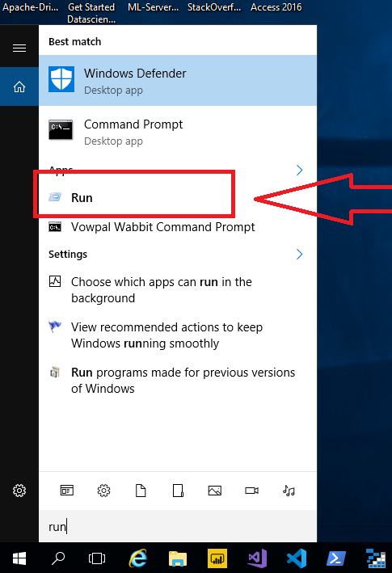 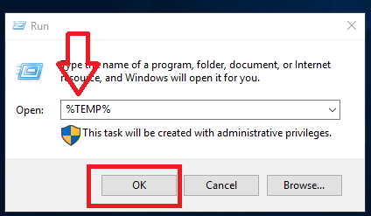

1. From the start menu or desktop shortcut, open **‘Microsoft SQL Server Management Studio’.**

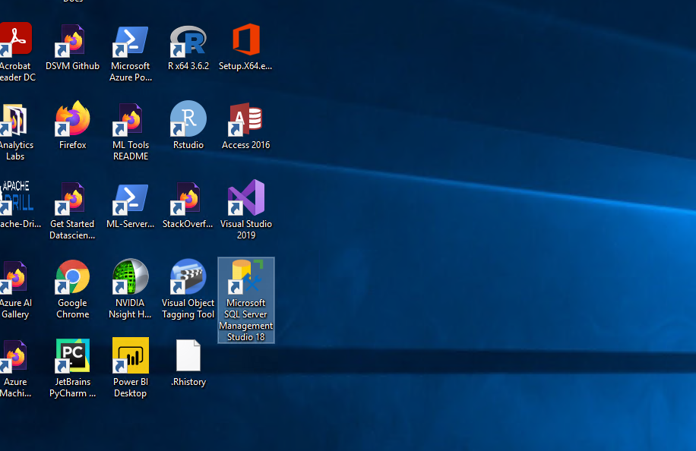

1. The following window show up, select server name which starts with ‘**ML’** and authentication as **Windows Authentication**. Click on **Connect**.

1. From the side bar select **Databases** and right click and select **New Database**.

1. Give the database name and click **OK**. You don’t need to edit anything in the database files section.

1. The created database in this case *MyOWNDb* shown in the left side section under **Databases** folder. If it doesn’t show up, click on **Refresh (circling arrow icon)**.

1. You will see your database (that you just created) listed under Databases folder at the **Object Explorer**  
   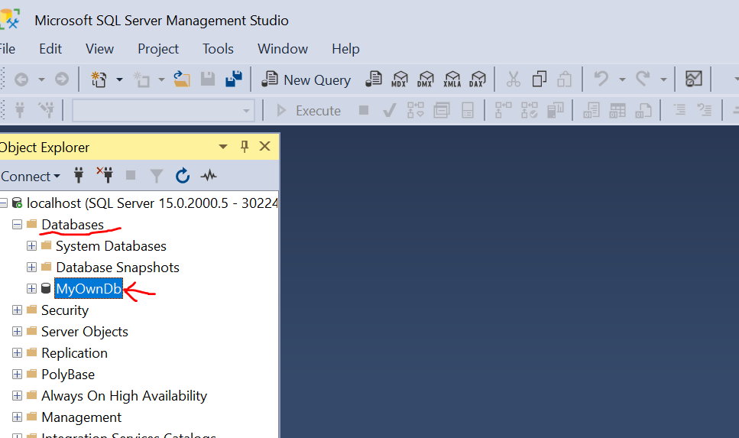
2. Right click on your database name, and select “**New Query**”   
      
   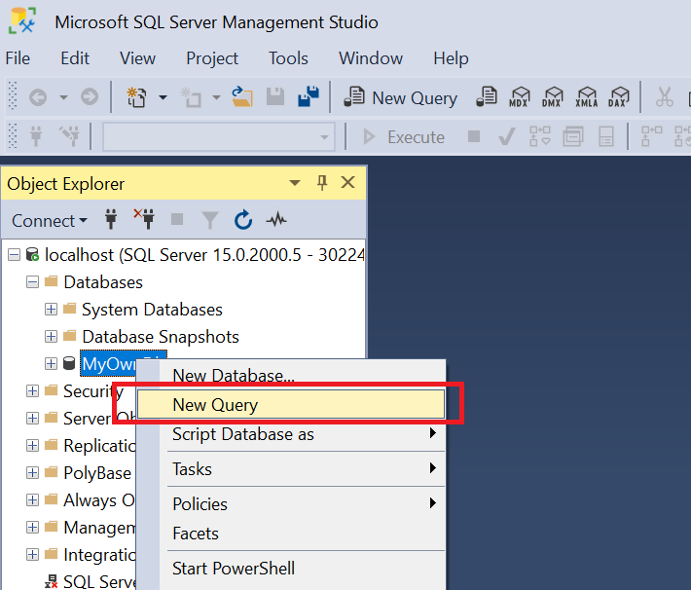
3. This will open a new “SQLScript.sql” file in a new tab   
   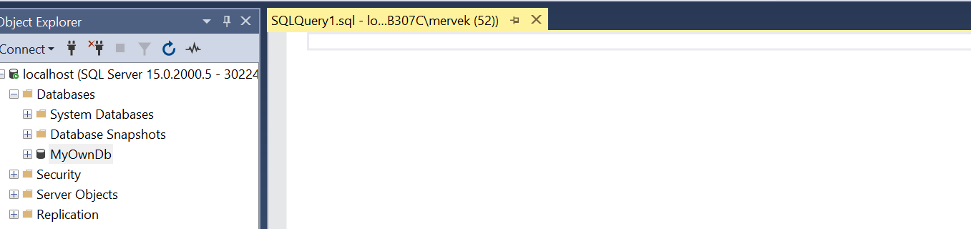
4. Copy and paste the entire contents of “hubspot_query.txt” (provided with the assignment) to this query window, make sure the database selected is the correct one.  Then click on **Execute** to run the script.   
    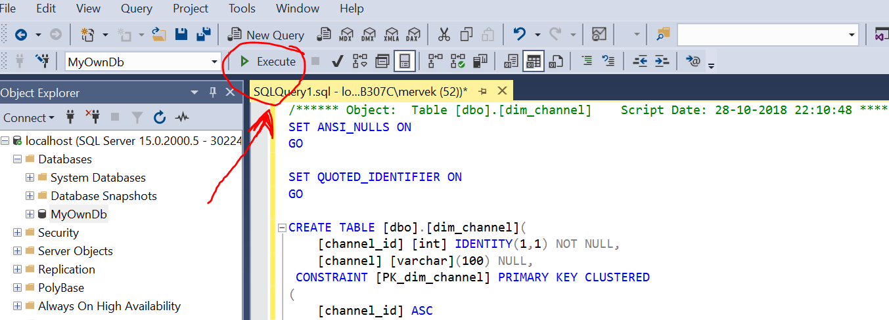
5. Review the confirmation message indicating “Commands completed successfully”  
      
      
    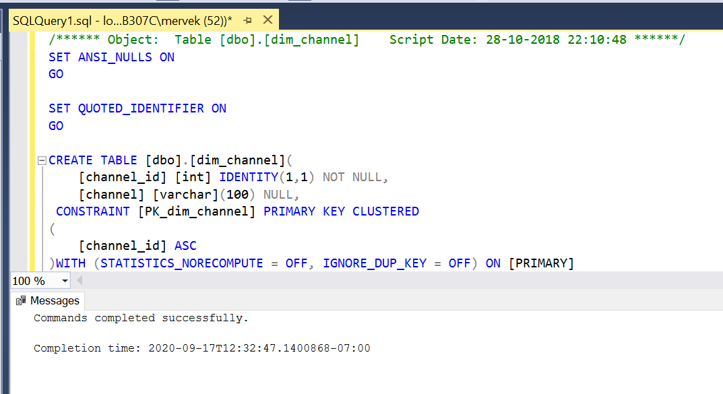
6. Refresh the **Object Explorer** window, and you should be able to see your new tables under the “**Tables**” tab

   
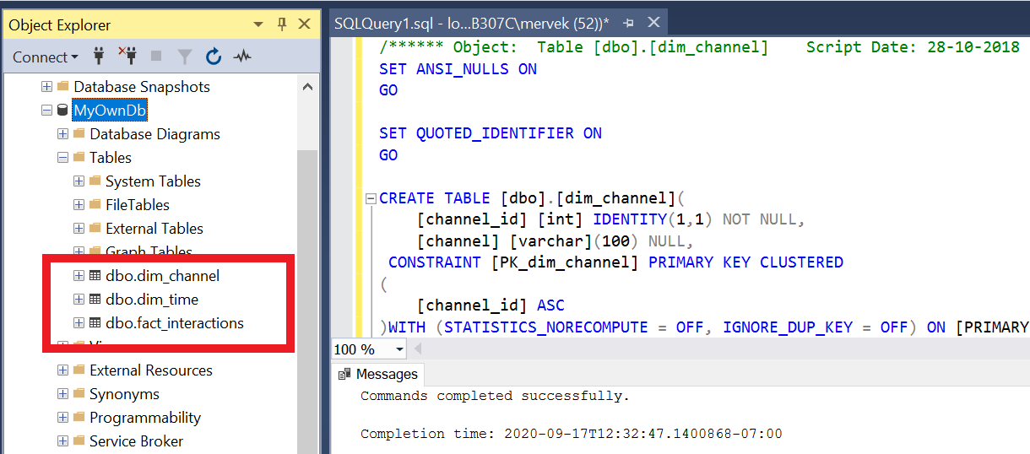

Now you have created your database and tables. You’re ready to move on to the next tutorial: **3_SQL Server Integration Services Tutorial**